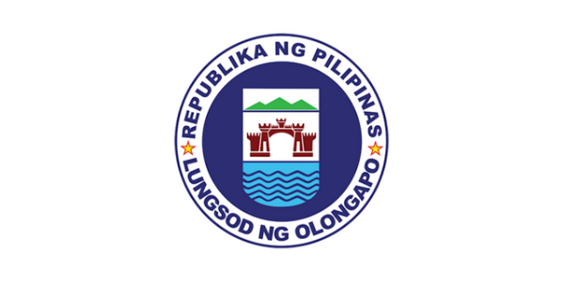
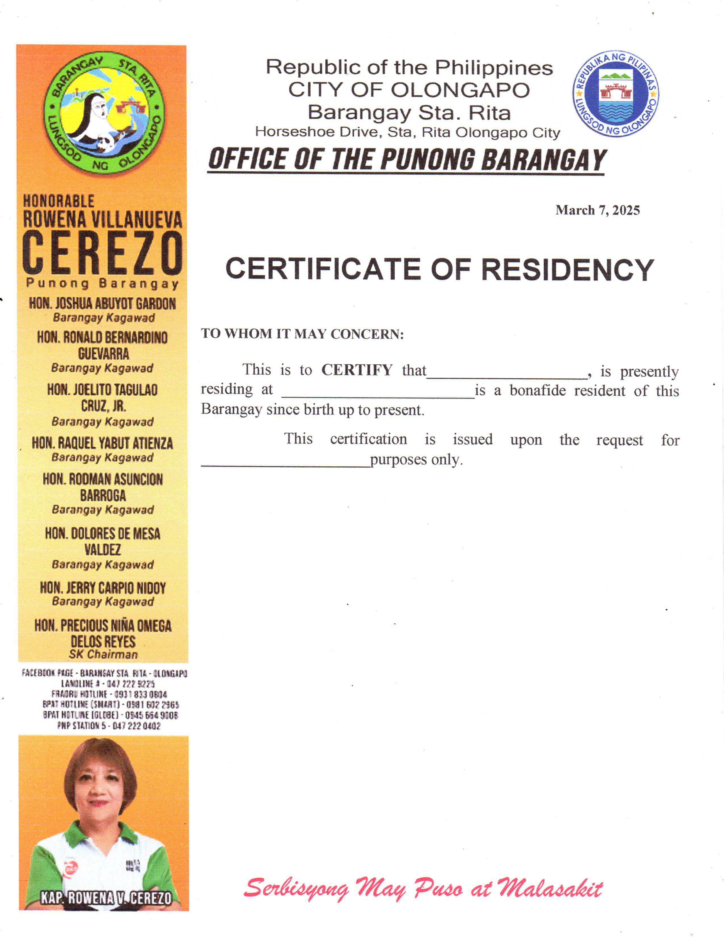
Republic of the Philippines CITY OF OLONGAPO Barangay Sta. Rita Horseshoe Drive, Sta. Rita Olongapo City OFFICE OF THE PUNONG BARANGAY
{dateRequested}

BARANGAY INDIGENCY

TO WHOM IT MAY CONCERN:
This is to CERTIFY that {fullName}, is presently residing at {address} personally appeared in this office and declared that he/she has no sufficient source of income to provide funds for his/her studies.
Further certify that subject person belongs to indigent families of this Barangay

This CERTIFICATION is issued upon the request for {purpose} purposes.
This certificate is valid until {validUntil}.

